200 W High-Speed BLDC Motor
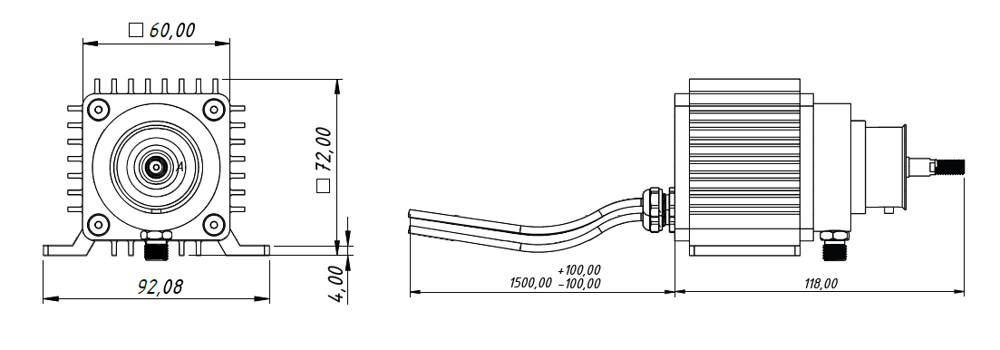
Basic Motor Parameters
Rated Power | W | 200
Rated Speed | rpm | 20000
Rated Torque | Nm | 0,07
Rated Current | A | 20
Rated Voltage | V | 12
No-Load Speed | rpm | 22000
Max. Efficiency | % | 90
Electrical Parameters
Number of Phases |  | 3
Number of Poles |  | 8
Torque Constant (KT) | Nm/A | 0.0034m
Back EMF Constant (KE) | Vs/rad | 0.0038
Terminal Resistance Phase to Phase (±%10) | mΩ | 10
Terminal Inductance Phase to Phase (±%30) | mH | 7.5
Thermal Data
Ambient Temperature | °C | -40...+85
Max. Winding Temperature | °C | +155
Physical Parameters
Outer Diameter | mm | 60x60 (Square)
Shaft Diameter | mm | 7
Max. Lenght | mm | 118
Weight | gr | 750
Motor Connection
U | Black Cable
V | White Cable
W | Red Cable
Sensor Connection
N/A | N/A
Connector Articles
Power | N/A
Signal | N/A

